**Make Division**

How did you find the target?

* We noticed a tweet from Dr. Evil that shown below that stated the Make Division was located at a remote site:
* 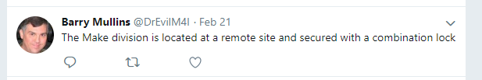
* We then recalled from the Security Procedures found on manuscripts.m4i.local/security that “employees” are allowed access to the remote site if they make a request in person to Chief Security officer.
* 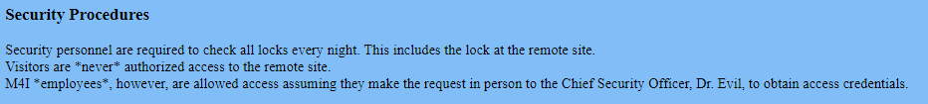
* Dr. Evil then posted on his twitter feed: twiter.com/DrEvilM4I the below tweet which showed us his new badge (which he apparently loves):
* 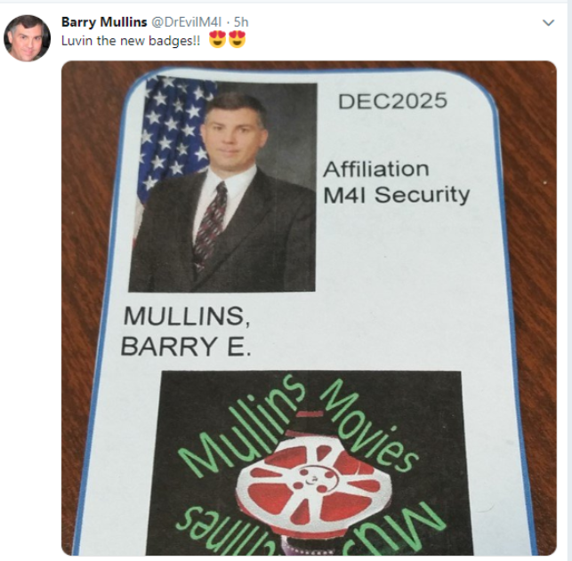
* We then created a fake credential based on the posted security badge on the DrEvilM4I Twitter:

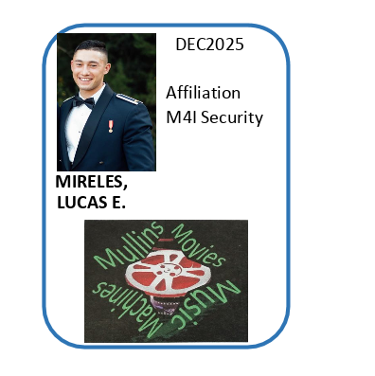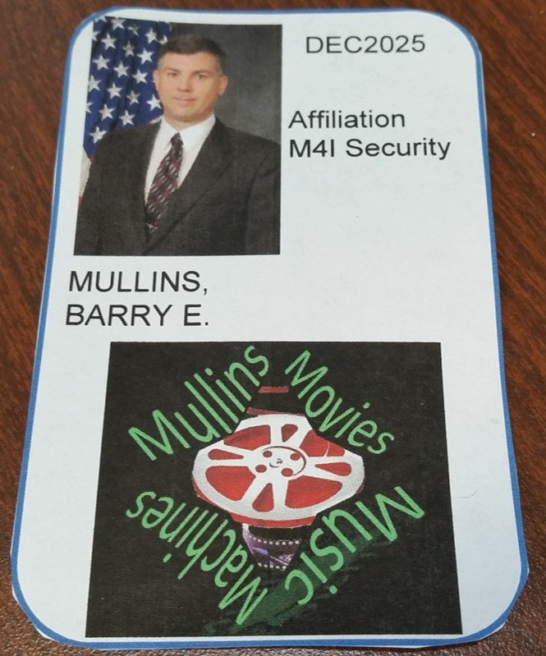

* With the fake credentials, we approached the Chief Security Officer and requested credentials to the remote site
* He then gave us a block of wood that was “secured” with a combination lock that contained the credentials for the remote site
* We were able to gain access to the below “Ticket #1” by unscrewing the latch that the lock was attached to.
* 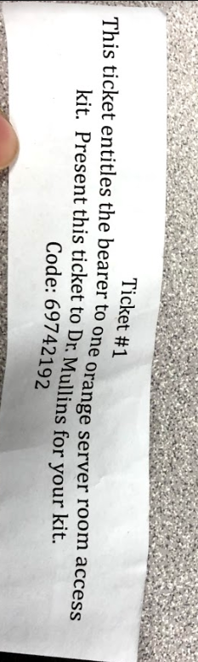
* We were then presented an orange server room access kit with a combination lock
* Using the User Table learned from the Music division that was found using an SQL injection, we had the combination for the orange server room as shown below:
* 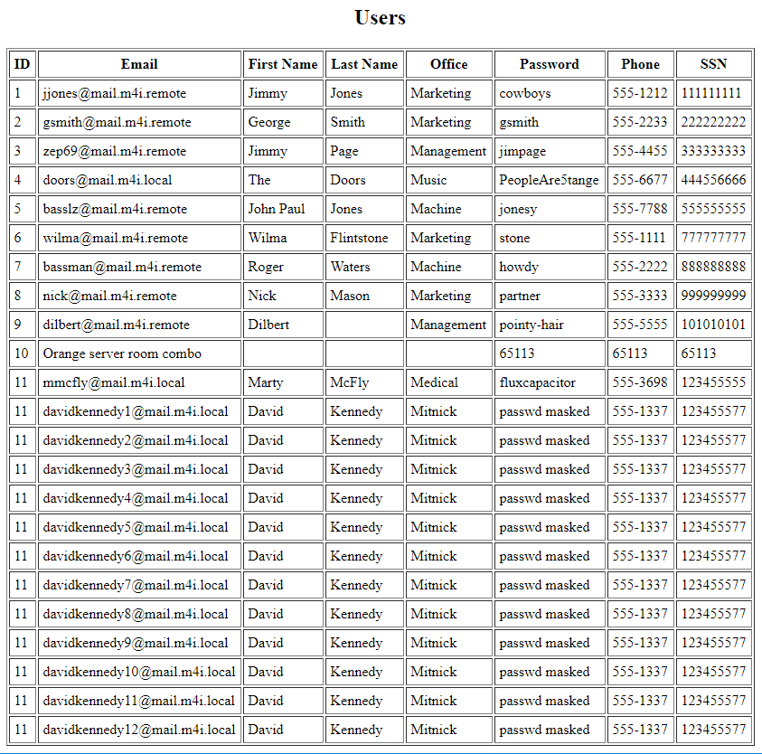
* We were then successfully able to gain access to the remote site that contained the Make division:
* 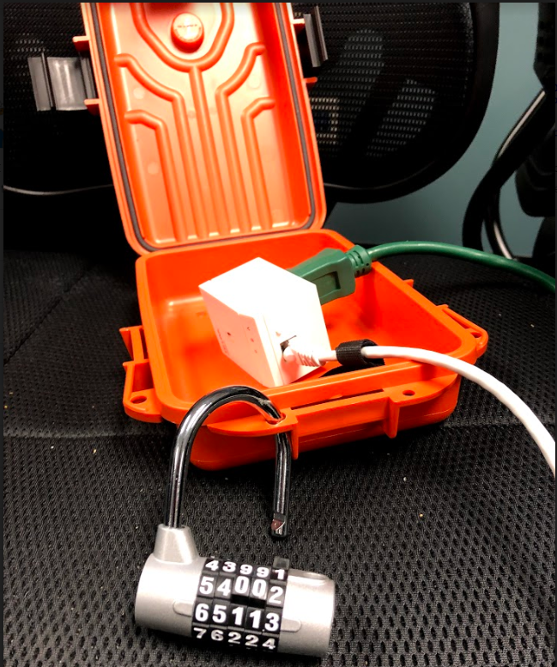
* We discovered that the device inside of the orange server room was a Powerline Adapter for Ethernet by searching “TP-link 600mps” (the words on the front of the device) in amazon:
* 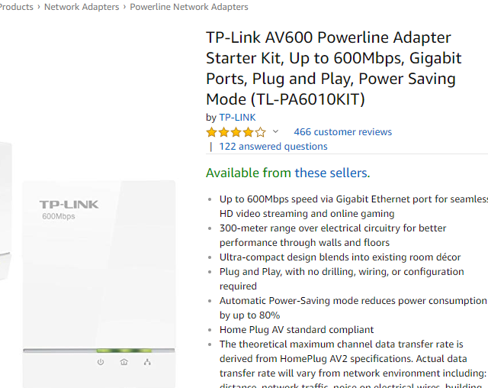
* We then plugged the device directly in the electric outlet in the wall and connect the device with an Ethernet cable to an usb adapter to our computer.
* In our Linux VM, we connected the Ethernet Device to our machine as shown below then ran “ifconfig” from a command terminal to learn the IP address that was given to our machine from the DHCP. Our IP address was “10.11.11.185”
* 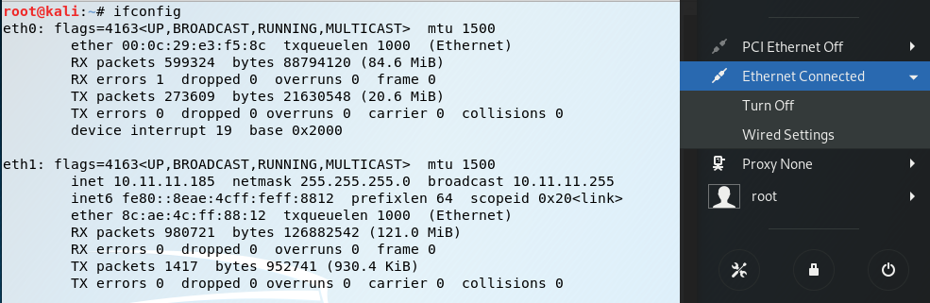
* Using the information learned from the Team IP Mapping document, we knew that for Team #1, that the Make Division’s last octet for its IP address ended in 191. Therefore, based on the IP address given to us by the DHCP, we did an Intense Scan, No Ping NMap scan of “10.11.11.191” in Armitage.
* 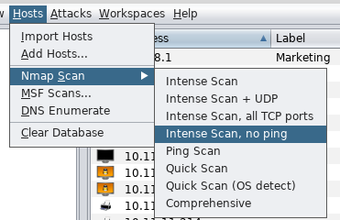
* 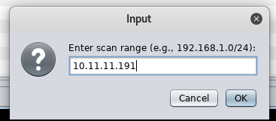
* Below is the result of the Nmap Scan showing that the machine is indeed Make1 Division:
* 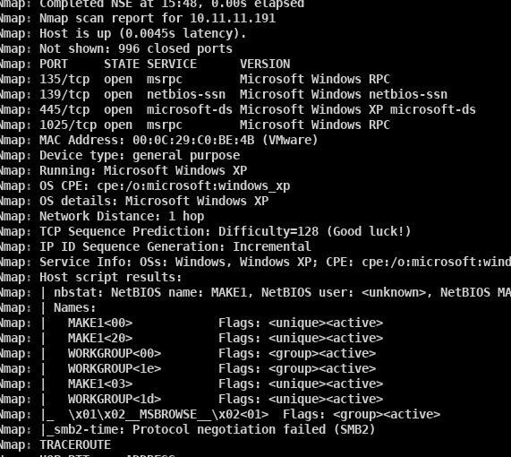
* After the initial Nmap scan to find the Make1 division box, we performed another Nmap scan using Zenmap to discover the remaining possible devices on Make based on the Team IP listings. We performed the below command in Zenmap
* 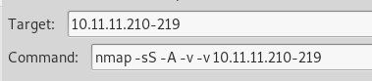
* The result is shown below:
* 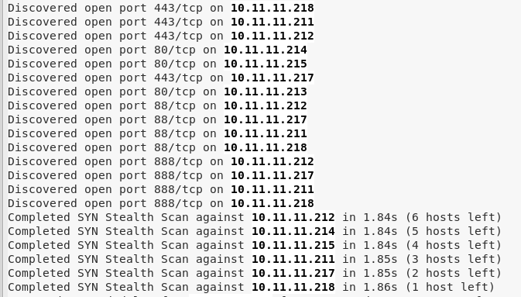
* We noticed that 10.11.11.213 has port 80 open meaning that it had a web server (http uses port 80). We then navigated to 10.11.11.213 using our browser whose title said Power Controller and were prompted with the following login.
* 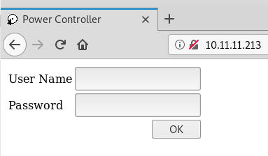
* Based on the Screenshot of the Make1 machine shown below (discussed the discovery in the “harvesting other files” section) we knew that there were multiple devices with web servers on this network associated with the secret process (6 total and we have found 1).
* 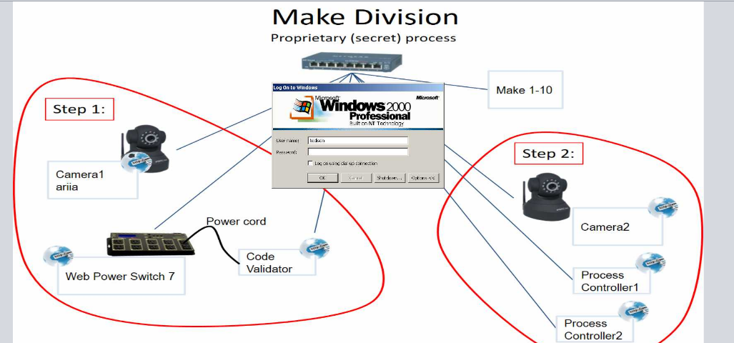
* From the previous Nmap results, we saw that 10.11.11.214,215 both had port 80 open as well. Thus, they had web servers
* 
* We then navigated to 10.11.11.214 using our browser which resulted in the below “green” page titled M4I Make Division Manual Override:
* 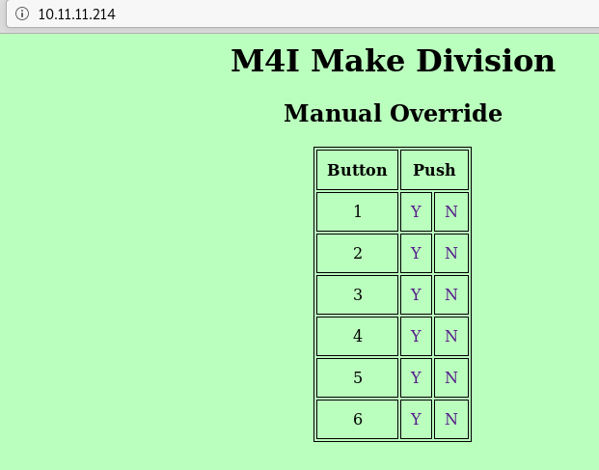
* We proceeded to navigate to 10.11.11.215 using our browser which resulted in the below “red” page titled M4I Make Division Manual Override:
* 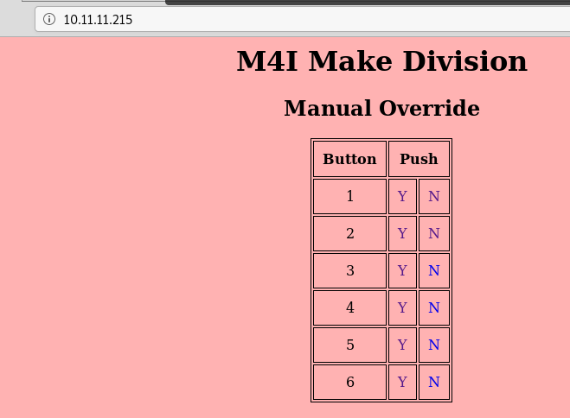
* (3/6 devices of the devices of the secret process have now been discovered)
* We noticed that 10.11.11.211 has port 88 open. According to our Nmap results, port 88 on this device offers http as its service.
* 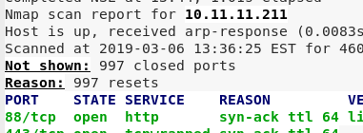
* Because of this, we navigated to 10.11.11.211:88 using our browser to access the web server.
* 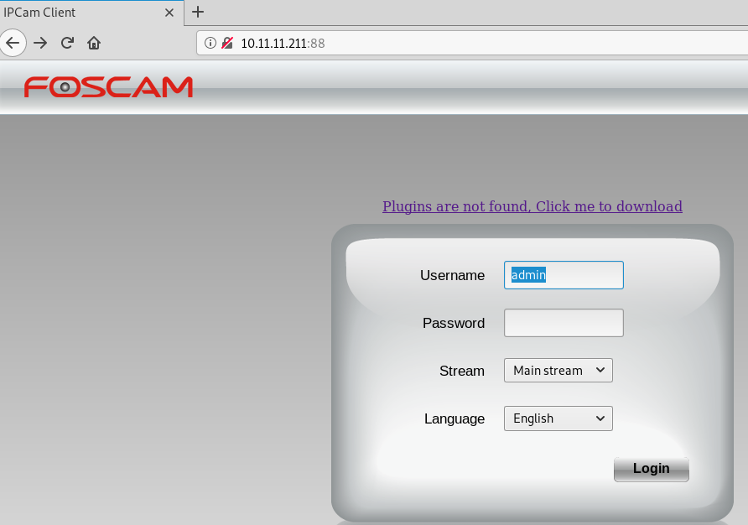
* We did a quick google search of “FOSCAM” to determine that the interface we had found was a type of security camera:
* 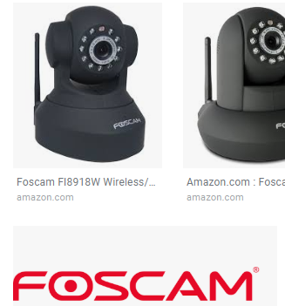
* We determined that this was 1 of the 2 cameras shown in the secret process.
* We now have 4/6 devices apart of the secret process discovered.
* We again noticed that port 88 was open on 10.11.11.212 via the Nmap scan and offered http on port 88.
* 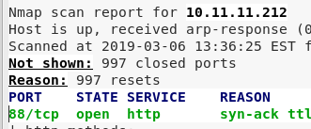
* We navigated to 10.11.11.212:88 using our browser which resulted in the below page:
* 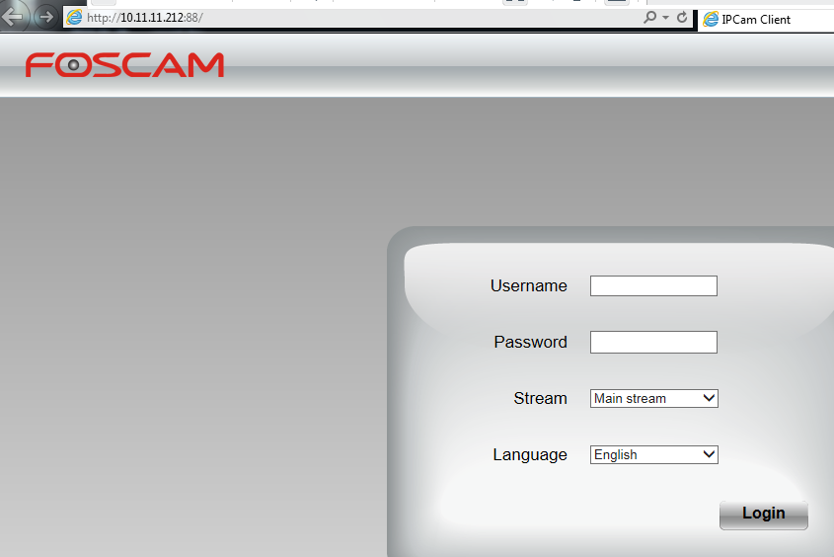
* We have now found the 2 cameras apart of the secret process and only have 1 remaining device found.
* We recalled that web page found at 10.11.11.213 after logging in as user (gaining access to this web page is discussed later) was the interface for the web power switch and that it had the “Code Validator” switched off. The secret process also shows that the Code Validator has a web server however no devices were initially found via the Nmap scan that matched this description, therefore we switched the Code validator on by clicking the “Switch ON” button next to the Code Validator. The resulting image shows the Code Validator ON
* 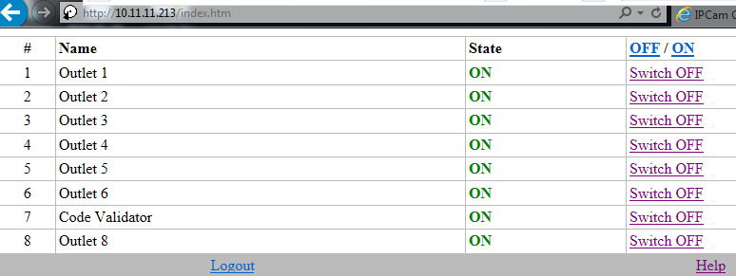
* We then performed an Nmap scan identical to the one before to see if any more devices appeared.
* 
* The results from this Nmap scan show a new device at 10.11.11.216 has port 80 open.
* 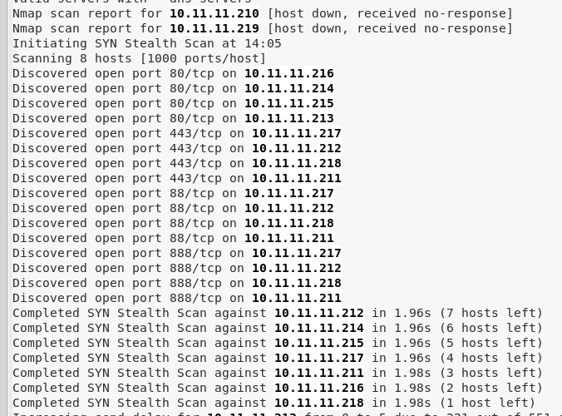
* We then navigated to the now accessible web page (while the Code Validator is switched ON) by navigating to 10.11.11.216 using our browser. The below web page was discovered and we have now found all 6 devices that are apart of the secret process along with the Make1 machine.

How did you gain access to the target?

MAKE1

* As mentioned previously, we did an Intense Scan, No Ping Nmap scan of “10.11.11.191” in Armitage
* How we executed the Nmap scan is also shown above.
* The command used by Armitage to perform this scan is shown below:
* 
* We discovered that Make1’s OS was running Windows XP and had port 135,139,445,1025 open with their services listed below:
* 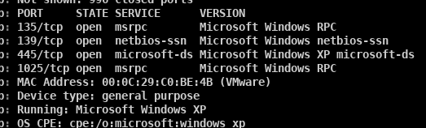
* Based on the open ports and services that were present and the OS Windows XP, we needed to find the potential vulnerabilities that could be exploited by clocking Find Attacks in Armitage which would then gather a list of potential exploits to gain access
* 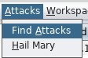
* After Armitage presented the potential list of exploits, we used the following exploit to gain access to Make1 with SYSTEM credentials.
* 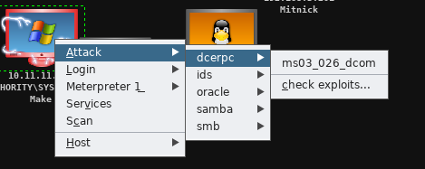
* 
* Below is the description of the module used:
* 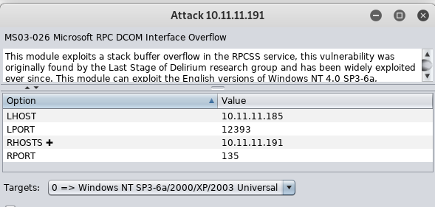

10.11.11.213

* We navigated to 10.11.11.213 using our browser. We then entered the default login username: user and password: user (discussed in password and user sections), to gain access to the web interface for the Web Power Switch controller.
* 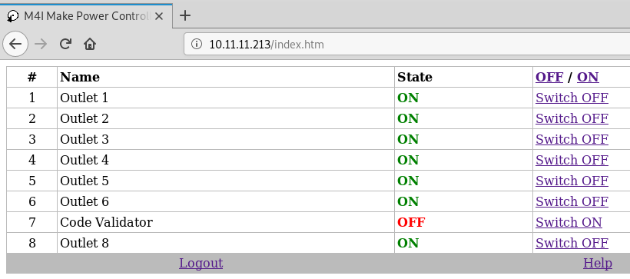

10.11.11.211

* We noticed that plugins needed to be installed in order to interact with the web interface, therefore we switched to a Windows 7 machine in order to download and install the plugins.
* The screenshot from Make1 shows that the secret process has 2 cameras, one whose name is “ariia.” Based on the web page displayed at 10.11.11.211 and some reconnaissance of what FOSCAM was, we knew that this was a web interface for one of the two cameras.
* To determine which camera, we first navigated to 10.11.11.211 using our browser. We then entered “user” as the username with and “user” as the password to see the error that it would throw. It returned the below error message suggesting that “user” was not a username for this camera.
* 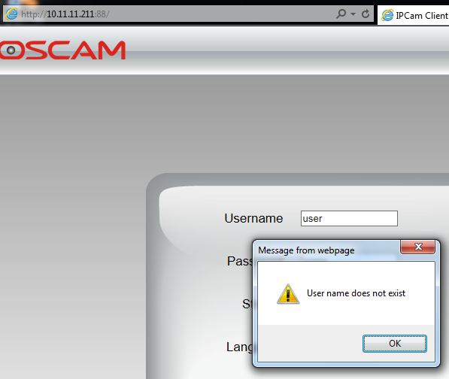
* We then entered “ariia” as the username with “ariia” as the password to see if ariia was indeed a username so we could determine which camera this is.
* 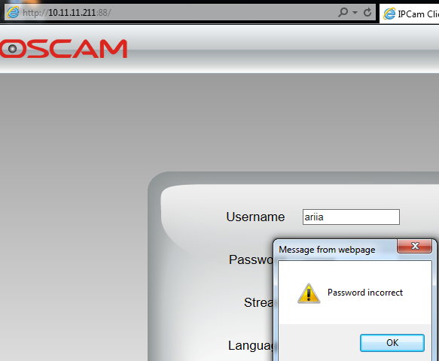
* We now knew that this was camera 1 because according to the secret process diagram found, camera 1’s name is ariia
* We then logged in to camera 1 using the correct credentials with Username: aria and Password: eagle1eye.
* The below snippet shows camera 1 after gaining access.
* 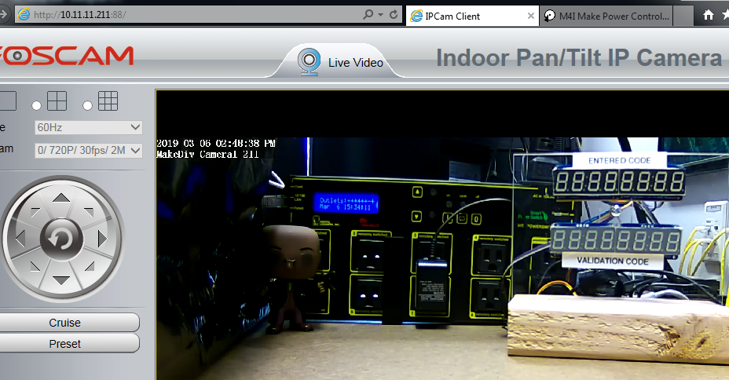

10.11.11.,214,215,216

* We navigated to their respective IP addresses using our browser. For 10.11.11.216, I needed to ensure that the Code Validator was turned on to access its web interface. There was no login required.

10.11.11.212

* We navigated to 10.11.11.212:88 in our browser. Because we had already found camera 1, we knew that this was camera 2. Thus, based on the “yellow sticky” (discussed in the username and password sections below), we entered our validation code of “14516309” as the username and “c56926” as the password.
* 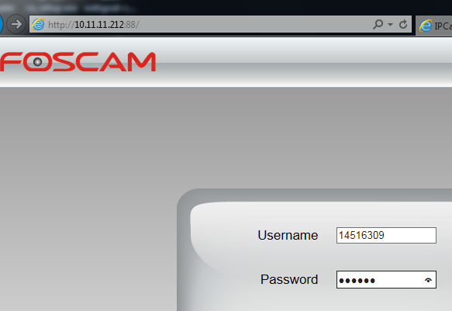
* The below screenshot shows us successfully gaining access to camera 2
* 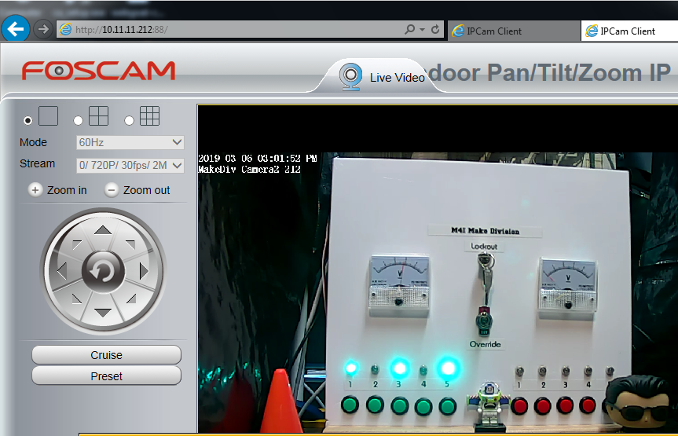

How did you learn usernames?

Make1

* We began by opening a command shell on Make1
* 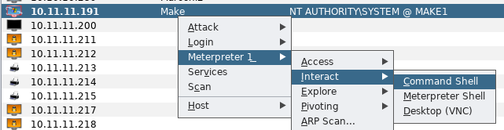
* We then entered “net user” in the command shell to display the usernames on the Make1 Division Machine.
* 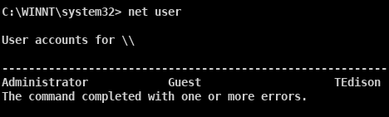

10.11.11.213 (Web Power Switch)

* To find the user name for the web power switch, we recalled that on the manuscripts.m4i.local server, there was a document about a web power switch controller that had a web interface and included default logins.
* 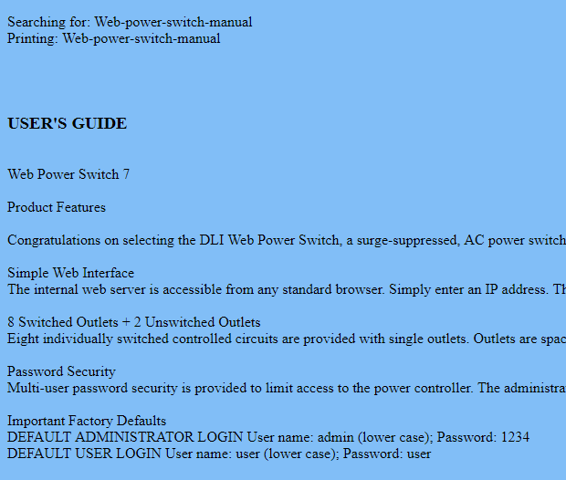
* The usernames for power switch were user and admin.

10.11.11.211(camera 1)

* In the gaining access section for the Make Division, we determined that this target was camera 1.
* Based on the secret process diagram gained from the screenshot of Make1, we knew that the username for camera 1 was “ariia”
* 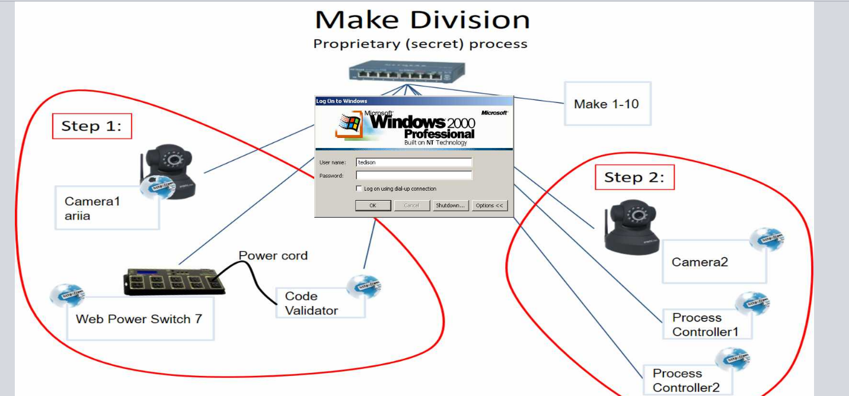

10.11.11.212(camera 2)

* After gaining access to camera 1, we had the ability to control the camera’s view. We then began exploring the surroundings of camera 1 and discovered the following yellow sticky note.
* 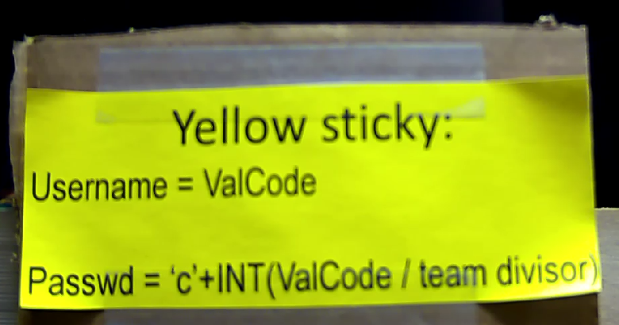
* Based on a tweet from Dr. Evil, we knew that camera 2’s password has a format that began with a c followed by numbers.
* 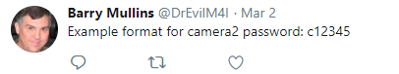
* Thus we knew that this was the format for the login information for camera 2
* We did not have the validation code yet so we needed to get it
* On camera 1 we were also able to locate the Code Validator. The Code Validator turned ON is shown below with no input and no output
* 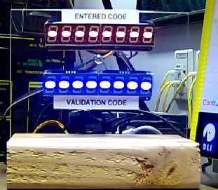
* We then navigated to the Code Validator interface at 10.11.11.216 when the code validator was on using our browser. We noticed that the code validator web interface was displaying the inputs in its URL after clicking on multiple buttons displayed on the web page. Thus, we entered the code that was given to us on the Ticket when we were given the orange server room credentials into the URL as shown below:
* 
* 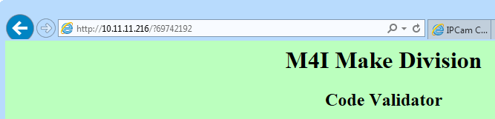
* The Code validator then displayed our correct validation code which is the Username for Camera 2: “14516309”
* 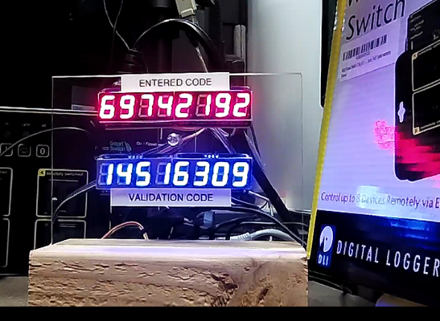

How did you learn passwords?

Make1

* After gaining access to the Make1 machine described above, we dumped the hashes using the lssass method in Armitage.
* 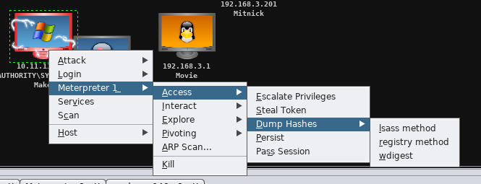
* 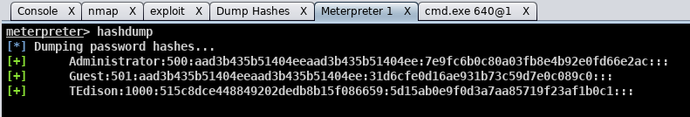
* To find TEdison’s password, we saw that Dr. Evil tweeted that he was the creator of movies and that his password only contained letters
* 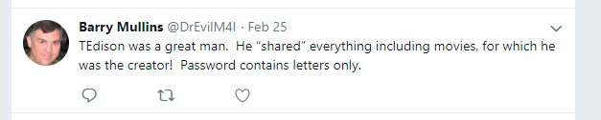
* Using cain, we loaded his hashes gained from the hashdump and ran a bruteforce attack against his LM hashes using only letters.
* 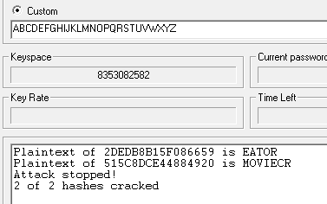
* Below is showing a correct password for TEdison:
* 
* To determine the password for the Web Power Switch 7, we recalled that on the manuscripts.m4i.local server had a document about a web power switch controller that had a web interface and included default logins.

10.11.11.213

* To find the password for the web power switch, we recalled that on the manuscripts.m4i.local server, there was a document about a web power switch controller that had a web interface and included default logins.
* 
* With the default login username: user and password: user, we attempted to gain access to the web page to determine if this was the correct password. The following image shows a successful login thus the password for 10.11.11.213 is “user”
* 

10.11.11.211

* In flag18.txt that was found on the Mitnick1 Machine, we learned that the username and password were found in picture named “very-intersting.jpg”
* The very-ineresting.jpg image is shown below
* 
* We did a reverse google image search using the above image as the search. We discovered the “ariia” is shown in the image and that it was from the movie “Eagle Eye”
* Thus, we knew that the password for camera 1 was “found” in this image because its username is ariia.
* We also saw from D. Evil’s twitter that arria’s password contained 1 number.
* 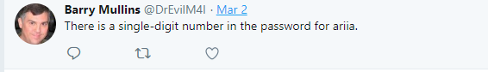
* Thus we believed that the password contained the movie title “Eagle Eye” and contained a single number. We then began a brute force attack attempting to log on to camera 1 using the username “ariia”. The passwords that we used varied the capitalization of “EagleEye” and added a number before, in the middle of the two words, or after the two words.
* We were able to successfully login to camera 1 with the password of “eagle1eye” which is shown below:
* 

10.11.11.212(camera 2)

* As mentioned in the username section for camera 2, we found a yellow sticky note shown below on camera 1:
* 
* Additionally, from the username section of camera 2, we discovered that the validation code for our team was 14516309.
* At the beginning of the penetration test, we were given a team divisor of “255”
* 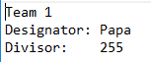
* Thus, using the equation found in the password section of the yellow sticky note, we derived our password to be “c56926”. (we rounded down our result)
* We were successfully able to login to camera 2 using the password found above as shown below after navigating to 10.11.11.212:88 in our browser:
* 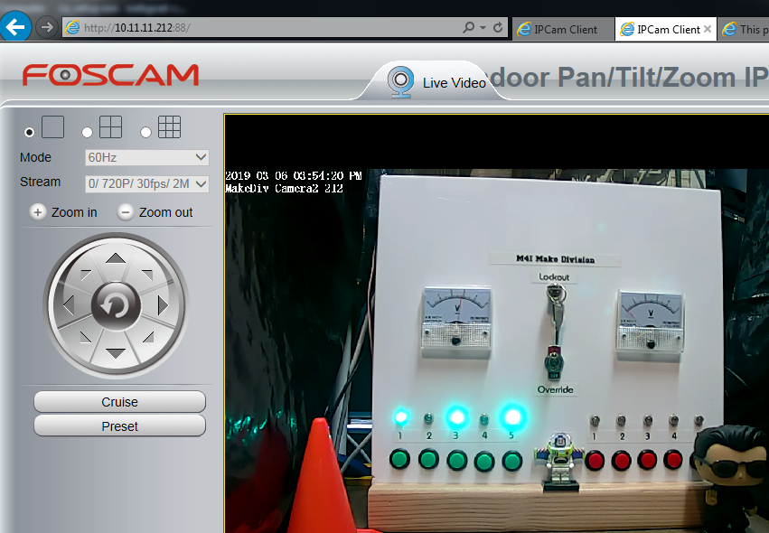

How did you find and download flags?

* Form the home directory, we executed “dir “flag*” /a /s /p” in the command line to find where any flags may be. We discovered that flag21.txt was located in the below directory:
* 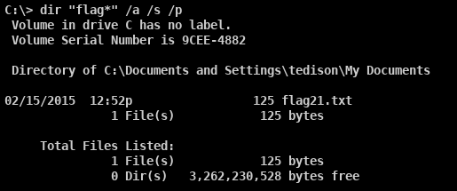
* We then performed “net share” from the command line and learned that tedison has his own share
* 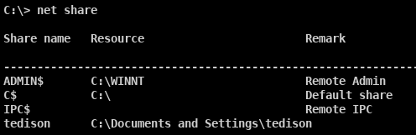
* Using a windows 7 machine, we then mapped his share to our local device using the below command with user: “tedison” and password: “moviecreator” and navigated to the shared drive:
* 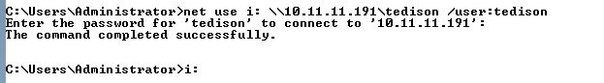
* We then navigated to the location found above for flag21.txt. We then executed “type flag21.txt” from the command line display the flag in the console:
* 

How did you find and download any other files you may have harvested from the target?

* After gaining access to Make1, we took a screen shot of the machine using the method below:
* 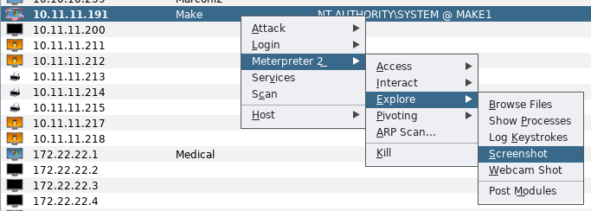
* The result of the screenshot is shown below:
* 

|  |  |  |
| --- | --- | --- |
| **Username** | **Account Type** | **Password** |
| TEdison |  | Moviecreator |
| user |  | user |
| Administrator |  |  |
| Ariia |  |  |